**AIM: Android program to work with google maps and location.**

* **THEORY:**

1. Location:

* A data class representing a geographic location.
* The Location object represents a geographic location which can consist of a latitude, longitude, time stamp, and other information such as bearing, altitude and velocity.
* All locations generated through LocationManager are guaranteed to have a valid latitude, longitude, and timestamp (both UTC time and elapsed real-time since boot).
* Methods of this object are:

1. float distanceTo(Location dest)- Returns the approximate distance in meters between this location and the given location.
2. float getAccuracy()- Get the estimated accuracy of this location, in meters.
3. double getAltitude()- Get the altitude if available, in meters above sea level.
4. float getBearing()- Get the bearing, in degrees.
5. double getLatitude()- Get the latitude, in degrees.
6. double getLongitude()- Get the longitude, in degrees.
7. Android Google Map:

* Android provides facility to integrate Google map in our application.
* Google map displays your current location, navigate location direction, search location etc.
* We can also customize Google map according to our requirement.
* Google map API provides several methods that help to customize Google map.
* These methods are as following:

1. addCircle(CircleOptions options): This method add circle to map.
2. addPolygon(PolygonOptions options): This method add polygon to map.
3. addTileOverlay(TileOverlayOptions options): This method add tile overlay to the map.
4. animateCamera(CameraUpdate update): This method moves the map according to the update with an animation.
5. clear(): This method removes everything from the map.
6. getMyLocation(): This method returns the currently displayed user location.
7. moveCamera(CameraUpdate update): This method reposition the camera according to the instructions defined in the update.
8. setTrafficEnabled(boolean enabled): This method set the traffic layer on or off.
9. snapshot(GoogleMap.SnapshotReadyCallback callback): This method takes a snapshot of the map.
10. stopAnimation(): This method stops the camera animation if there is any progress.

**A) Add marker method to be used in application students are creating.**

* **CODE:**
  + **MapsActivity.java:**

package com.example.mapdemo;

import android.Manifest;

import android.content.Context;

import android.content.pm.PackageManager;

import android.location.Address;

import android.location.Criteria;

import android.location.Geocoder;

import android.location.Location;

import android.location.LocationManager;

import android.os.Build;

import android.os.Bundle;

import android.widget.Toast;

import androidx.core.app.ActivityCompat;

import androidx.core.content.ContextCompat;

import androidx.fragment.app.FragmentActivity;

import com.google.android.gms.common.ConnectionResult;

import com.google.android.gms.common.api.GoogleApiClient;

import com.google.android.gms.location.LocationListener;

import com.google.android.gms.location.LocationRequest;

import com.google.android.gms.location.LocationServices;

import com.google.android.gms.maps.CameraUpdateFactory;

import com.google.android.gms.maps.GoogleMap;

import com.google.android.gms.maps.OnMapReadyCallback;

import com.google.android.gms.maps.SupportMapFragment;

import com.google.android.gms.maps.model.BitmapDescriptorFactory;

import com.google.android.gms.maps.model.LatLng;

import com.google.android.gms.maps.model.Marker;

import com.google.android.gms.maps.model.MarkerOptions;

import com.google.*;

import com.google.maps.android.SphericalUtil;

import java.io.IOException;

import java.util.List;

import java.util.Locale;

public class MapsActivity extends FragmentActivity implements OnMapReadyCallback,

GoogleApiClient.ConnectionCallbacks,

GoogleApiClient.OnConnectionFailedListener,

LocationListener {

public static final int MY_PERMISSIONS_REQUEST_LOCATION = 99;

GoogleApiClient mGoogleApiClient;

Location mLastLocation;

Marker mCurrLocationMarker;

LocationRequest mLocationRequest;

private GoogleMap mMap;

Double distance;

@Override

protected void onCreate(Bundle savedInstanceState) {

super.onCreate(savedInstanceState);

setContentView(R.layout.activity_maps);

if (android.os.Build.VERSION.SDK_INT >= Build.VERSION_CODES.M) {

checkLocationPermission();

}

SupportMapFragment mapFragment = (SupportMapFragment)

getSupportFragmentManager()

.findFragmentById(R.id.map);

mapFragment.getMapAsync(this);

}

@Override

public void onMapReady(GoogleMap googleMap) {

mMap = googleMap;

mMap.setMapType(GoogleMap.MAP_TYPE_NORMAL);

mMap.getUiSettings().setZoomControlsEnabled(true);

mMap.getUiSettings().setZoomGesturesEnabled(true);

mMap.getUiSettings().setCompassEnabled(true);

//Initialize Google Play Services

if (android.os.Build.VERSION.SDK_INT >= Build.VERSION_CODES.M) {

if (ContextCompat.checkSelfPermission(this,

Manifest.permission.ACCESS_FINE_LOCATION)

== PackageManager.PERMISSION_GRANTED) {

buildGoogleApiClient();

mMap.setMyLocationEnabled(true);

}

} else {

buildGoogleApiClient();

mMap.setMyLocationEnabled(true);

}

}

protected synchronized void buildGoogleApiClient() {

mGoogleApiClient = new GoogleApiClient.Builder(this)

.addConnectionCallbacks(this)

.addOnConnectionFailedListener(this)

.addApi(LocationServices.API)

.build();

mGoogleApiClient.connect();

}

@Override

public void onConnected(Bundle bundle) {

mLocationRequest = new LocationRequest();

mLocationRequest.setInterval(1000);

mLocationRequest.setFastestInterval(1000);

mLocationRequest.setPriority(LocationRequest.PRIORITY_BALANCED_POWER_ACCURACY);

if (ContextCompat.checkSelfPermission(this,

Manifest.permission.ACCESS_FINE_LOCATION)

== PackageManager.PERMISSION_GRANTED) {

LocationServices.FusedLocationApi.requestLocationUpdates(mGoogleApiClient,mLocationRequest, this);

}

}

@Override

public void onConnectionSuspended(int i) {

}

@Override

public void onLocationChanged(Location location) {

mLastLocation = location;

if (mCurrLocationMarker != null) {

mCurrLocationMarker.remove();

} LatLng latLng = new LatLng(location.getLatitude(), location.getLongitude());

MarkerOptions markerOptions = new MarkerOptions();

markerOptions.position(latLng);

LocationManager locationManager = (LocationManager)

getSystemService(Context.LOCATION_SERVICE);

String provider = locationManager.getBestProvider(new Criteria(), true);

if (ActivityCompat.checkSelfPermission(this,

Manifest.permission.ACCESS_FINE_LOCATION) != PackageManager.PERMISSION_GRANTED &&

ActivityCompat.checkSelfPermission(this, Manifest.permission.ACCESS_COARSE_LOCATION)

!= PackageManager.PERMISSION_GRANTED) {

return;

}

Location locations = locationManager.getLastKnownLocation(provider);

List<String> providerList = locationManager.getAllProviders();

if (null != locations && null != providerList && providerList.size() > 0) {

double longitude = locations.getLongitude();

double latitude = locations.getLatitude();

Geocoder geocoder = new Geocoder(getApplicationContext(),

Locale.getDefault());

try {

List<Address> listAddresses = geocoder.getFromLocation(latitude,

longitude, 1);

if (null != listAddresses && listAddresses.size() > 0) {

String state = listAddresses.get(0).getAdminArea();

String country = listAddresses.get(0).getCountryName();

String subLocality = listAddresses.get(0).getSubLocality();

markerOptions.title("" + latLng + "," + subLocality + "," + state

+ "," + country);

}

} catch (IOException e) {

e.printStackTrace();

}

}

markerOptions.icon(BitmapDescriptorFactory.defaultMarker(BitmapDescriptorFactory.HUE_BLUE));

mCurrLocationMarker = mMap.addMarker(markerOptions);

mMap.moveCamera(CameraUpdateFactory.newLatLng(latLng));

mMap.animateCamera(CameraUpdateFactory.zoomTo(11));

if (mGoogleApiClient != null) {

LocationServices.FusedLocationApi.removeLocationUpdates(mGoogleApiClient,

this);

}

}

@Override

public void onConnectionFailed(ConnectionResult connectionResult) {

}

public boolean checkLocationPermission() {

if (ContextCompat.checkSelfPermission(this,

Manifest.permission.ACCESS_FINE_LOCATION)

!= PackageManager.PERMISSION_GRANTED) {

if (ActivityCompat.shouldShowRequestPermissionRationale(this,

Manifest.permission.ACCESS_FINE_LOCATION)) {

ActivityCompat.requestPermissions(this,

new String[]{Manifest.permission.ACCESS_FINE_LOCATION},

MY_PERMISSIONS_REQUEST_LOCATION);

} else {

ActivityCompat.requestPermissions(this,

new String[]{Manifest.permission.ACCESS_FINE_LOCATION},

MY_PERMISSIONS_REQUEST_LOCATION);

}

return false;

} else {

return true;

}

}

@Override

public void onRequestPermissionsResult(int requestCode, String permissions[], int[] grantResults) {

super.onRequestPermissionsResult(requestCode, permissions, grantResults);

switch (requestCode) {

case MY_PERMISSIONS_REQUEST_LOCATION: {

if (grantResults.length > 0

&& grantResults[0] == PackageManager.PERMISSION_GRANTED) {

if (ContextCompat.checkSelfPermission(this,

Manifest.permission.ACCESS_FINE_LOCATION)

== PackageManager.PERMISSION_GRANTED) {

if (mGoogleApiClient == null) {

buildGoogleApiClient();

}

mMap.setMyLocationEnabled(true);

}

} else {

Toast.makeText(this, "permission denied",

Toast.LENGTH_LONG).show();

}

return;

}}}}

* + **Activity_maps.xml:**

<?xml version="1.0" encoding="utf-8"?>  
<fragment xmlns:android="http://schemas.android.com/apk/res/android"  
 xmlns:map="http://schemas.android.com/apk/res-auto"  
 xmlns:tools="http://schemas.android.com/tools"  
 android:id="@+id/map"  
 android:name="com.google.android.gms.maps.SupportMapFragment"  
 android:layout_width="match_parent"  
 android:layout_height="match_parent"  
 tools:context=".MapsActivity" />

* **OUTPUT:**

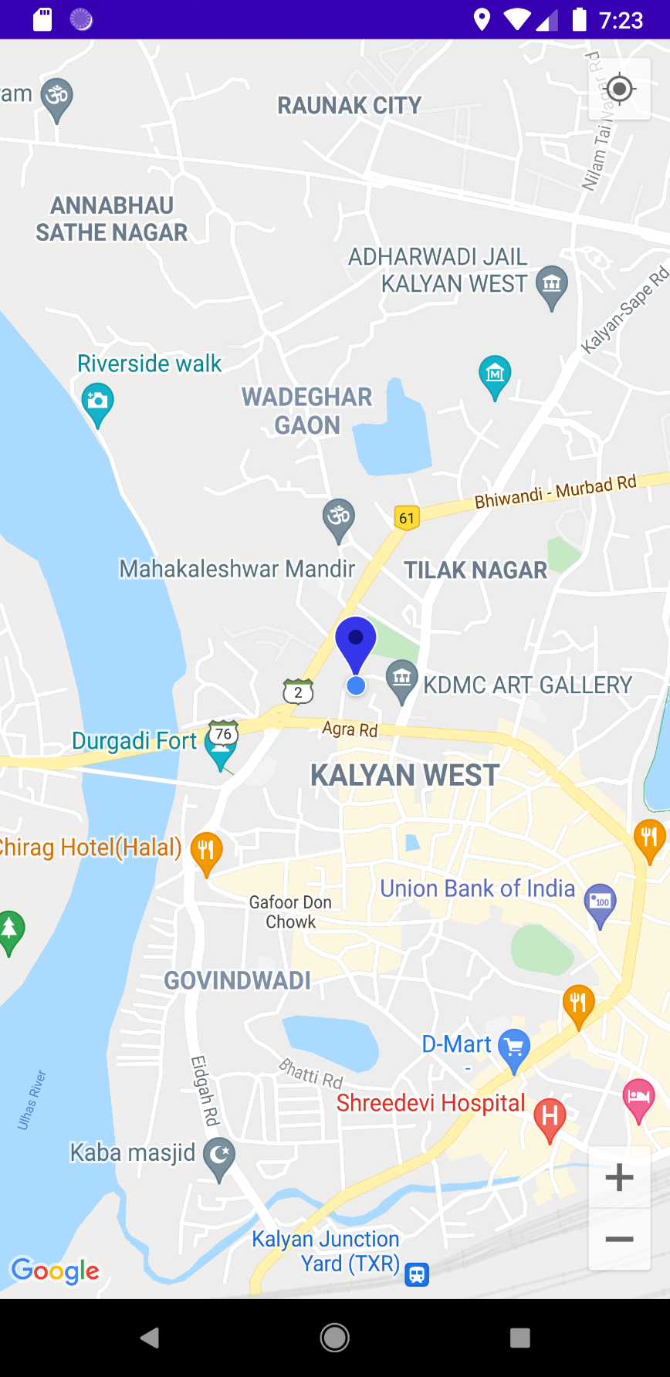

**B) Calculate route distance between two locations.**

* **CODE:**
  + **MapsActivity.java:**

package com.example.practical7_a;  
  
import android.os.Bundle;  
import android.widget.Toast;  
import androidx.fragment.app.FragmentActivity;  
import com.google.android.gms.maps.GoogleMap;  
import com.google.android.gms.maps.OnMapReadyCallback;  
import com.google.android.gms.maps.SupportMapFragment;  
import com.google.android.gms.maps.model.LatLng;  
import com.google.android.gms.maps.model.MarkerOptions;  
import com.google.maps.android.SphericalUtil;  
  
  
public class MapsActivity extends FragmentActivity implements OnMapReadyCallback {  
 private GoogleMap mMap;  
 LatLng home = new LatLng(19.24760301731887, 73.1221433756462);  
 LatLng college = new LatLng(19.04589540226512, 72.88918131108983);  
 Double distance;  
 @Override  
 protected void onCreate(Bundle savedInstanceState) {  
 super.onCreate(savedInstanceState);  
 setContentView(R.layout.*activity_maps*);  
 // Obtain the SupportMapFragment and get notified  
 // when the map is ready to be used.  
 SupportMapFragment mapFragment = (SupportMapFragment) getSupportFragmentManager().findFragmentById(R.id.*map*);  
 mapFragment.getMapAsync(this);  
 }@Override  
 public void onMapReady(GoogleMap googleMap) {  
 mMap = googleMap;  
 // on below line we are calculating the distance between sydney and brisbane  
 distance = SphericalUtil.*computeDistanceBetween*(home, college);  
 googleMap.addMarker(new MarkerOptions()  
 .position(home)  
 .title("Marker in Home"));  
  
 googleMap.addMarker(new MarkerOptions()  
 .position(college)  
 .title("Marker in College"));  
 Toast.*makeText*(this, "Distance between Home and College is \n " + String.*format*("%.2f", distance / 1000) + "km", Toast.*LENGTH_SHORT*).show();  
 }  
}

* + **Activity_maps.xml:**

<?xml version="1.0" encoding="utf-8"?>  
<fragment xmlns:android="http://schemas.android.com/apk/res/android"  
 xmlns:map="http://schemas.android.com/apk/res-auto"  
 xmlns:tools="http://schemas.android.com/tools"  
 android:id="@+id/map"  
 android:name="com.google.android.gms.maps.SupportMapFragment"  
 android:layout_width="match_parent"  
 android:layout_height="match_parent"  
 tools:context=".MapsActivity" />

* **OUTPUT:**

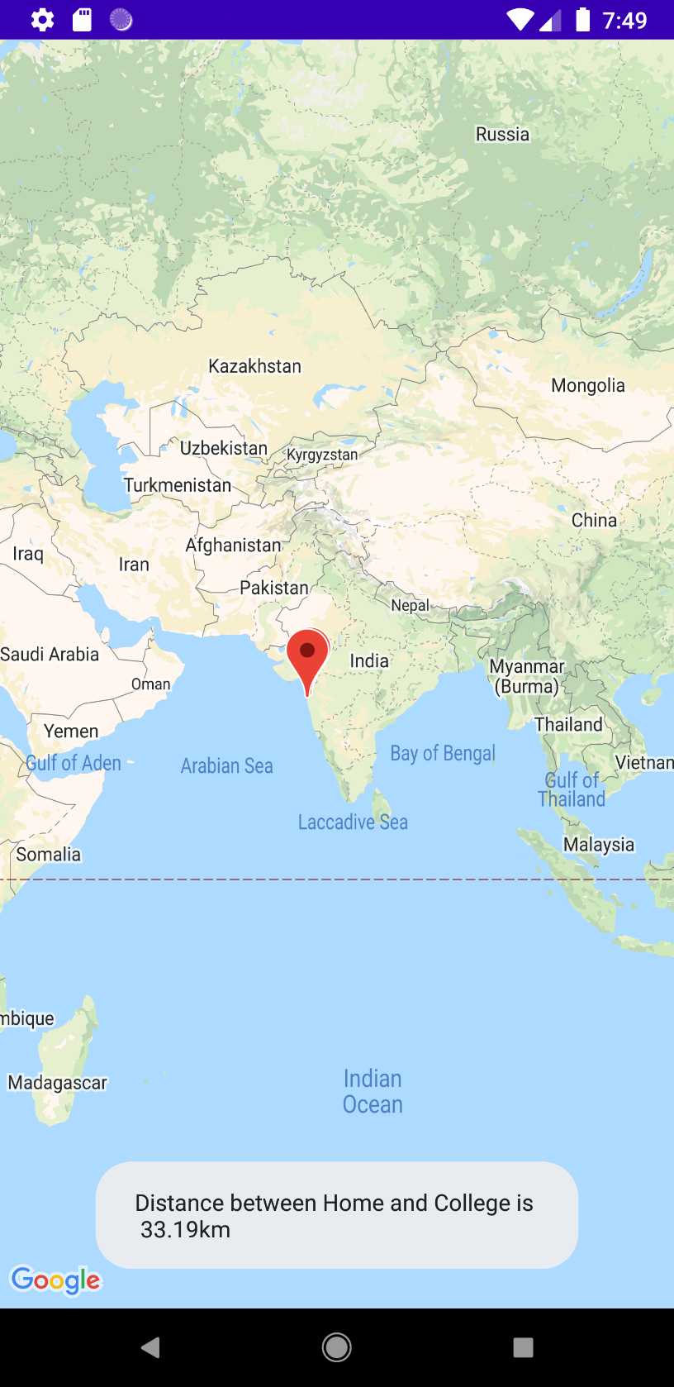

* **CONCLUSION:**

Hence we successfully implemented google maps and location.